**ACS 560 Software Engineering**

H2 Database

Name: Vijayagiridharan Subramanian

My SQL file loaded in H2 Console

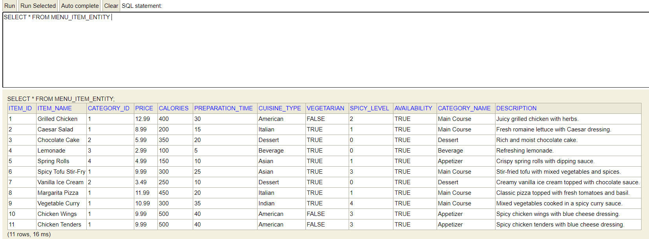

After created new item

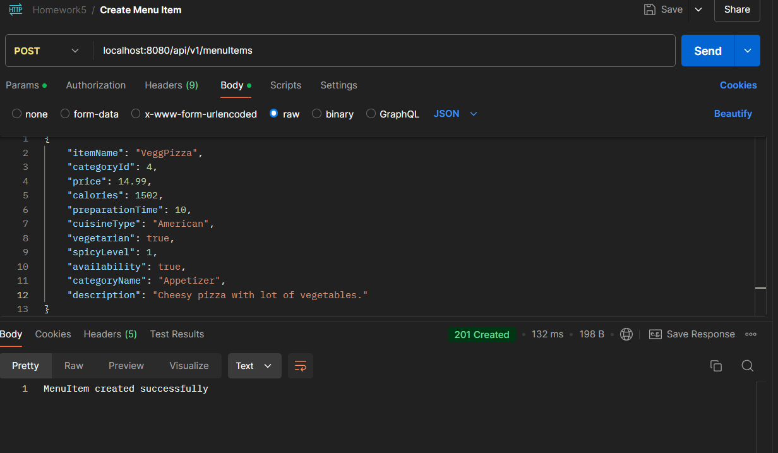

H2Console:

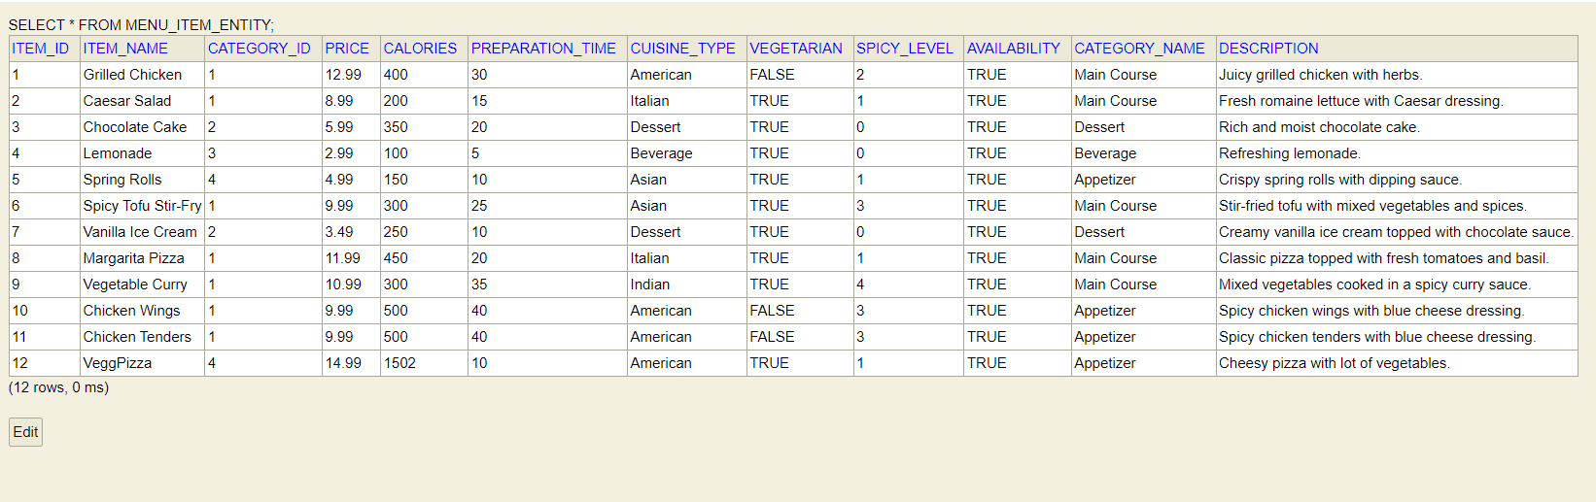

Updating Items:

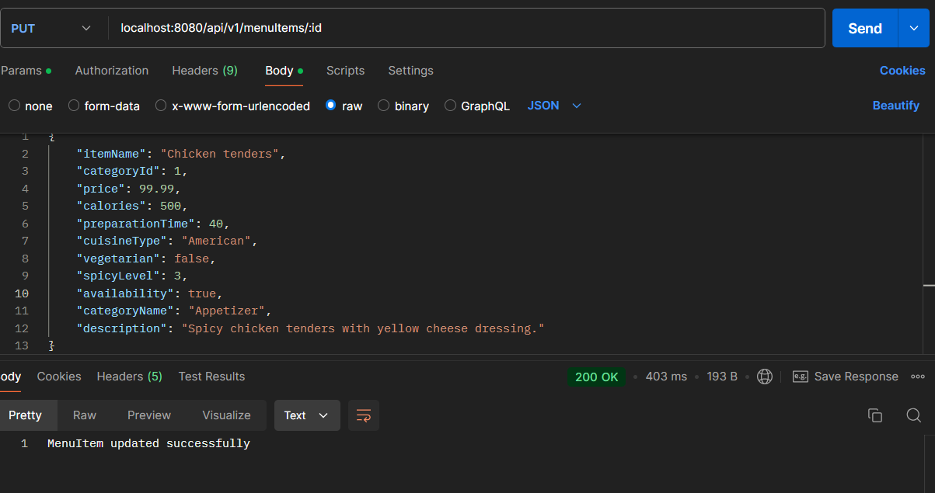

H2 Console:(updated)

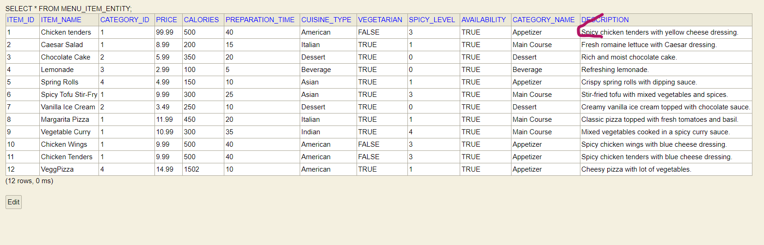

Deleting Items:(Deleting item 12)

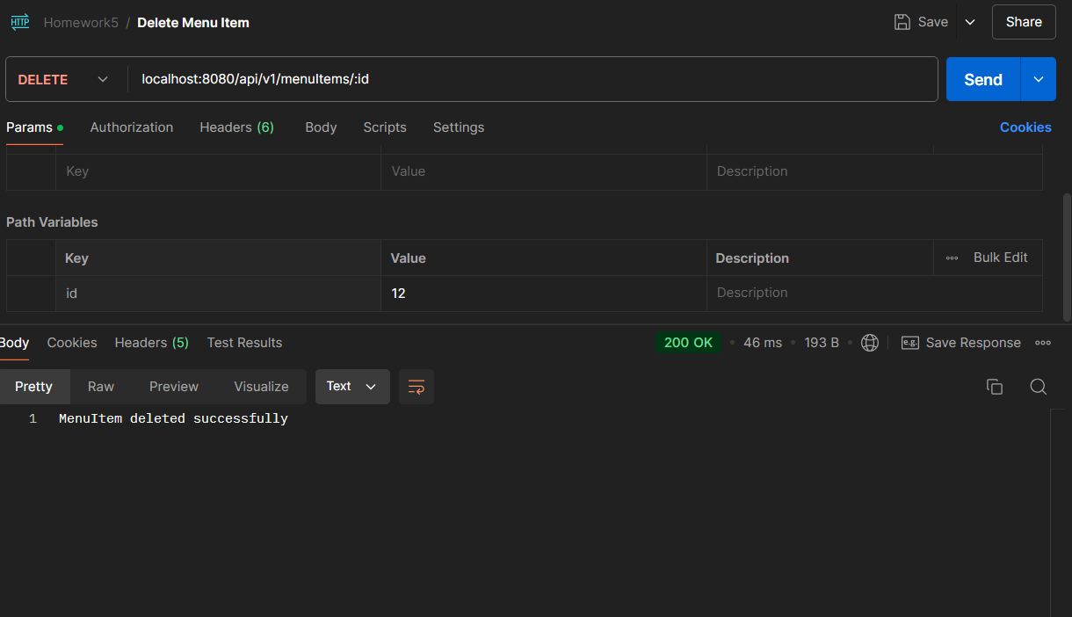

H2 Console:(after deleting item 12)

